Project Design Phase-II
Data Flow Diagram & User Stories

Date | 28 September 2026
Team ID | 6ab221341
Project Name | Implement Client Scripts & UI Policy (Incident)
Maximum Marks | 4 Marks

Data Flow Diagrams:
A Data Flow Diagram (DFD) represents the flow of incident information through the ServiceNow Incident Management system. It shows how incident details are entered by the user, processed using Client Scripts and UI Policies, and stored in the ServiceNow database. Client Scripts perform client-side actions such as validation and dynamic field updates, while UI Policies control the visibility, mandatory, and read-only properties of incident form fields.

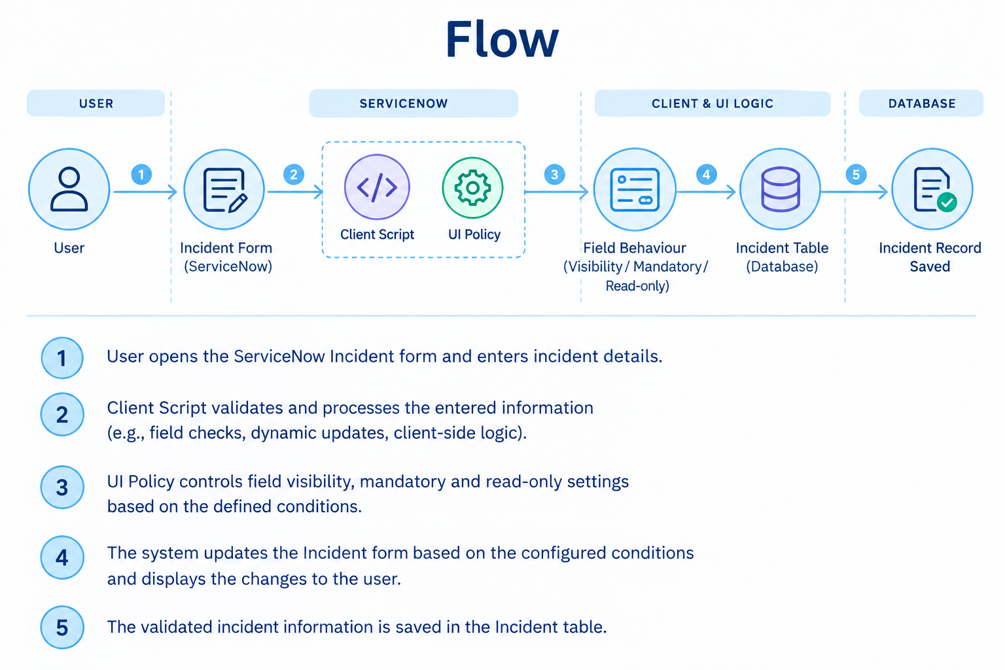
Example: (Simplified)
Flow
- User opens the ServiceNow Incident form.
- User enters or updates incident information.
- Client Scripts validate and dynamically process the entered data.
- UI Policies control field visibility, mandatory and read-only properties based on conditions.
- Valid incident information is submitted and stored in the ServiceNow Incident table.

Example: DFD Level 0 (Implement Client Scripts & UI Policies (Incident)

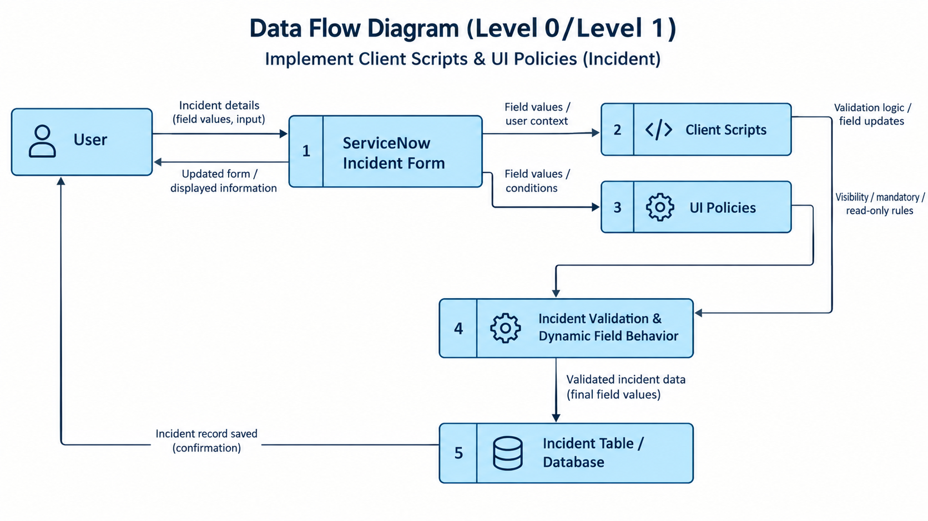

User Stories
Use the below template to list all the user stories for the product.

User Type | Functional Requirement (Epic) | User Story Number | User Story / Task | Acceptance Criteria | Priority | Release
Incident User | Incident Creation | USN-1 | As an incident user, I want to enter incident details so that I can create an incident record. | Required incident details can be entered and submitted successfully. | High | Sprint-1
Incident User | Client Script | USN-2 | As an incident user, I want the form to validate my input so that incorrect information can be identified before submission. | Invalid or incomplete information displays a validation message. | High | Sprint-1
Incident User | Field Behaviour | USN-3 | As an incident user, I want incident fields to change dynamically based on my selections. | Related fields update automatically when a field value changes. | High | Sprint-1
Incident User | UI Policy | USN-4 | As an incident user, I want fields to become mandatory when required. | Required fields become mandatory when the condition is satisfied. | High | Sprint-1
Incident User | UI Policy | USN-5 | As an incident user, I want unnecessary fields to be hidden based on conditions. | Fields are hidden or displayed according to the UI Policy condition. | Medium | Sprint-2
Incident User | UI Policy | USN-6 | As an incident user, I want certain fields to become read-only when required. | The specified field becomes non-editable when the condition is satisfied. | Medium | Sprint-2
Service Desk Agent | Incident Update | USN-7 | As a Service Desk Agent, I want to update incident information according to the configured form rules. | Fields behave according to the configured Client Scripts and UI Policies. | High | Sprint-2
Administrator | Configuration & Testing | USN-8 | As an Administrator, I want to configure and test Client Scripts and UI Policies so that the Incident form works correctly. | All configured scripts and policies execute according to their conditions. | High | Sprint-2

